***Google Summer Of Code 2025***

***Project :- Improving Synth & Sample Features in Music Blocks***

***Personal Details :-***

***• Name :- Irfan Riyad Shaikh (Irfanulhak)***

***• Email :- irfanulhawk@gmail.com***

***• Discord & Gitter :- irfan0504 & @iitzirfan:gitter.im***

***• GitHub Profile :-*** [iitzIrFan (Irfan)](https://github.com/iitzIrFan)

***• LinkedIn :-*** [Irfan Shaikh | LinkedIn](https://www.linkedin.com/in/irfan-shaikh-8b5b94259/)

***• Portfolio:*** <https://irfan-shaikh-portfolio.vercel.app/>

***• Availability :- 350 hours***

***1] Overview :-***

*Music Blocks offers a fun way to create music using synths and samples, but there is plenty of room to refine this tool. This project aims to improve the sample widgets, integrate a curated selection of high-quality free/open-samples and allow instruments to use multiple samples for a richer and more expensive sound. These updates will make Music Blocks more powerful and intuitive tool for music creation.*

***2] Why this matters :-***

* ***Easier to use*** *:- The sample widget will be more user-friendly and flexible.*
* ***Better Sound Library*** *:- Expanding the collection of samples will provide more variety.*
* ***More Realistic Playback*** *:- Multiple samples per instrument will provide more variety.*
* ***Stronger Performance*** *:- Upgrading Tine.js will ensure smoother functionality.*

***3. What I’ll Delive :-***

***3.1 Upgrading the sample widget :*-**

* *Update tone.js and resolve any breaking changes.*
* *Add a built in tuner to help with pitch adjustments.*
* *Implement fine tuning controls for more precise sample manipulation.*

***3.2 Expanding the Sample Library :-***

* *Convert and Integrate high-quality free samples into Music Blocks.*
* *Organize sounds by instrument type for easy access.*
* *Introduce visual instrument icons or improving navigation.*

***3.3 Enhancing Instrument & Sampler Features :-***

* *Enable multiple samples per instrument for more natural sound playback.*
* *Allow user-uploaded and recorded samples for custom instruments*
* *Improve sample selection logic to match note pitch and length dynamically.*

***4. How will I do it :-***

***4.1 Updating Tone.js & Improving the Sampler :-***

* *Identify incompatibilities in the latest version of Tone.js and fix them.*
* *Use the Web Audio API for real-time tuning and fine-tuning adjustments.*
* *Improve the user interface for a more intuitive experience.*

***4.2 Integrating & Organizing Samples :-***

* *Convert and process selected samples using guidelines from:*
  + [Music Blocks Sample Guide](https://wiki.sugarlabs.org/go/Music_Blocks/2025-02-09-meeting)
  + [Philharmonia Orchestra Samples](https://philharmonia.co.uk/resources/sound-samples/)
  + [Sonic Pi Sample Library](https://github.com/sonic-pi-net/sonic-pi/tree/dev/etc/samples)
* *Improve the UI with sample previews and better organization.*

***4.3 Implementing Multi-Sample Instruments :-***

* *Design an efficient data structure for storing multiple samples per instrument.*
* *Develop logic to dynamically select the best sample based on pitch, duration, and articulation.*
* *Seamlessly integrate user-uploaded and recorded samples into the system.*

|  |  |  |  |  |  |  |  |  |  |  |  |  |  |  |  |  |  |  |  |  |  |  |  |  |  |  |  |
| --- | --- | --- | --- | --- | --- | --- | --- | --- | --- | --- | --- | --- | --- | --- | --- | --- | --- | --- | --- | --- | --- | --- | --- | --- | --- | --- | --- |
| ***5] Timeline :-***   |  |  | | --- | --- | | *Week* | *Milestone* | | *Week-1* | ***Research Tone.js changes, finalize approach, and set up development environment*** | | *Week-2* | ***Begin updating Tone.js, fixing breaking changes, and testing compatibility*** | | *Week-3* | ***Implement and test tuner feature in sampler widget*** | | *Week-4* | ***Add fine-tuning controls and ensure smooth UX improvements*** | | *Week-5* | ***Convert and integrate initial batch of free samples into Music Blocks*** | | *Week-6* | ***Develop UI improvements for better sample browsing and selection*** | | *Week-7* | ***Organize samples by instrument type and introduce instrument icons*** | | *Week-8* | ***Develop logic for multiple sample assignments per instrument*** | | *Week-9* | ***Allow user-uploaded and recorded samples for custom instruments*** | | *Week-10* | ***Optimize sample selection logic based on pitch, duration, and articulation*** | | *Week-11* | ***Conduct comprehensive testing, bug fixes, and performance optimizations*** | | *Week-12* | ***Finalize documentation, prepare a demo, and submit final evaluation*** | |  |
|  |  |
| ***6. Challenges & Solutions :-***   |  |  | | --- | --- | | *Challenge* | *Solution* | | *Tone.js update breaking existing features* | *Test is an isolated environment and document changes.* | | *Handling multiple samples efficiently* | *Optimize data structures and minimize latency.* | | *Complex UI/UX improvements* | *Iterative design process with mentor feedback* | | *Processing a variety of sample formats* | *Define accepted formats and build a streamlined conversion process* | |  |

***UML Diagrams :-***

*To provide a clear visual representation of the project's structure and workflow, the following UML diagrams are included:*

* + 1. ***System Architecture Diagram :-***

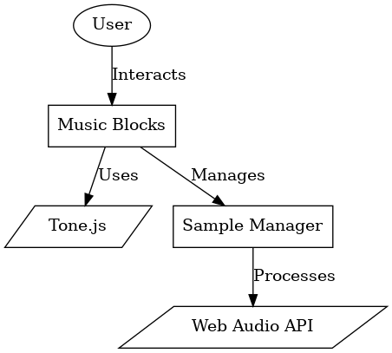

* + 1. ***Class Diagram :-***

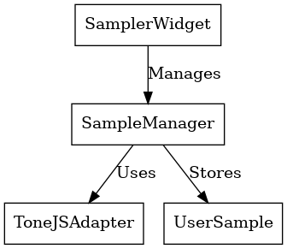

* + 1. ***Sequence Diagram :-***

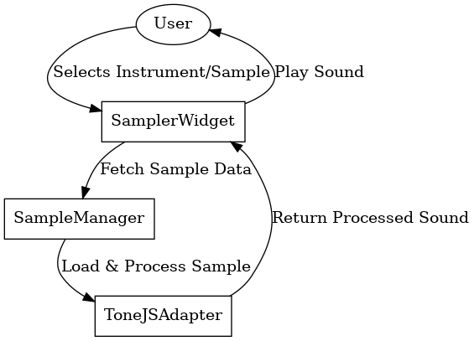

* + 1. ***State Diagram :-***

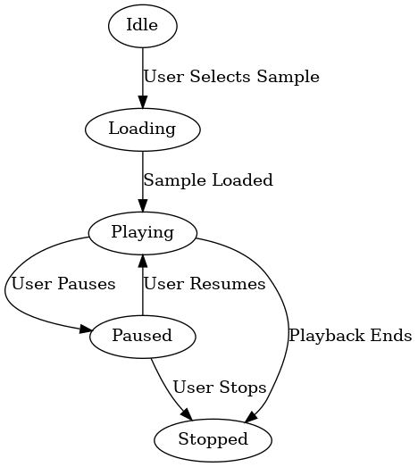

***Past Experience in Software Development :-***

***Why am I the best person to execute this proposal?***

I have actively contributed to *multiple open-source projects, focusing on frontend optimization, accessibility improvements, cross-platform compatibility, and documentation enhancements.* My contributions demonstrate *my ability to write clean, maintainable code and collaborate* effectively in open-source communities.

***Notable Contributions :-***

**1️⃣ Optimistic UI Improvements for Post Creation (***Hacktoberfest Contribution – Qwik Framework)*

*• Increased the level of detail through the use of shadow-md to ensure a better integration with the theme.*

*• Improved image loading with the lazy attribute to increase performance.*

*• Some of the changes made include; altering the typography, padding, and spacing to enhance the overall readability.*

**2️⃣ Improvements in the Accessibility of the Text Area Control** *(Hacktoberfest Contribution – Qwik Framework)*

*• Additional work was done to enhance the accessibility by adding proper labels and ARIA roles where necessary.*

*• Checked that all the text inputs had different IDs to avoid a situation where the same ID is used for different inputs.*

**3️⃣ Optimizations for Cross-Platform** *Compatibility (Qwik Web Framework)*

*• Fixed script compatibility issues by using concurrently instead of && so it can run on both Windows and Linux without a problem.*

**4️⃣ Improved Readme and Installation for ContribHub** *(Hacktoberfest Contribution – Next.js, Supabase)*

*• Improved the technology stack, the instructions that are provided for setting up the project as well as the project structure to make it easier for new contributors to get started.*

*• Offered a step by step guide on how to import the Supabase schema and explained in detail the process of contributing to the project.*

***Maintainer & Mentor Roles***

👨‍🏫 ***Mentor & Maintainer*** – ***Social Winter of Code*** *(SWoC 2024)*

* Guided contributors in React, Redux, and TailwindCSS.
* Conducted code reviews & mentoring sessions to enhance open-source best practices.

👨‍🏫 ***Mentor*** ***– GirlScript Summer of Code*** *(GSSoC 2024)*

* Led an open-source web project, assisting contributors in frontend and API integration.
* Reviewed PRs and designed scalable frontend architectures.

***Collaborative Open-Source Projects***

* 🍽️ **TastyTrails** *(Under GSSoC 2024)* – A recipe discovery web app using modern frontend technologies.
* 📖 **Matrubodhah** *(Under SWoC 2024)* – A cultural education platform.

***Planned GSoC work hours- commitments :-***

*I commit to dedicate 350+ hours to this project. I do not plan on any personal vacations. If anything comes up, I will inform the mentor and communicate it out especially during college & university exams.*

*My Working hours are as follows [Total – 350+ hours] :-*

*● ○ Weekdays: 4 Hours - (UTC +5:30)*

*○ Monday and Friday: 22:30 to 02:30 IST [Fixed]*

*● ○ Weekends: 5 Hours- (UTC +5:30)*

*○ Saturday and Sunday: 21:30 to 02:30 IST [Flexible]*

*● Estimated Hours Per Week: 30 hours*

*Based on the circumstances, I am willing to adjust and re-plan the timing.*

***Resources & References :-***

* [**Music Blocks Repository**](https://github.com/sugarlabs/musicblocks)
* [**Tone.js Documentation**](https://tonejs.github.io/)
* [**Music Blocks Sample Guide**](https://wiki.sugarlabs.org/go/Music_Blocks/2025-02-09-meeting)

Thank you !